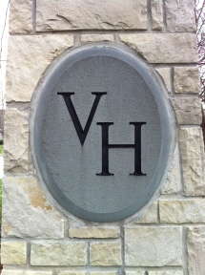**You Are Cordially Invited To Attend The Annual Meeting of The Verona Hills Homes Association**

**Wednesday, October 29, 2014**

**6:00 pm – 8:00 pm**

**Avila University - 11901 Wornall Road Whitfield Room**

(Hors d’oeuvres and drinks will be provided)

**Agenda:**

6:00 Social Gathering / Food and Drinks

7:00 Business Meeting:

* Election of New Member(s)
* Vote on Amendment of By-Laws
* Q&A

7:15 Past Verona Hills President Recognition

7:30 Guest Speakers

* Adrienne Hayes - Legal Aid of Western Missouri: Beneficiary Deeds: Non-Probate (No fee) transfer of your home
* Kevin Danciak, TITAN Protection & Consulting – Security Services for Verona Hills

7:45 Verona Hills Home’s Association Board of Directors, “What We Have Done For You Lately”

7:55 Prize Drawing /Adjourn

**Please RSVP** [**info@veronahills.org**](mailto:info@veronahills.org) **or Doris Holderness 816.941.9689**

**And let us know if you are attending the meeting only or**

**the Social Gathering & Meeting**

**RSVP Deadline Friday, October 23, 2014**

**We pay for the number responding, so PLEASE make our count accurate.**

Please join your neighbors and board members to share our vision and commitment for Verona Hills. We welcome your suggestions on improvements to our neighborhood.

Visit us on Facebook or at our website at [www.veronahills.org](http://www.veronahills.org)

for current neighborhood information.